Surname
Instructor’s Name
Course
Due Date
Discuss the differences between art and craft; art, artisan, and craftsperson; the minor arts and the major arts, and whether you think these distinctions are valuable or not.
In many times people tend to find it difficult differentiating between art and craft. Art is a term with no universal definition, but a term referring to any form of work that expresses emotions among other expressions and it is intangible in nature while craft is any form of work that is tangible, for example, objects in form of carvings or even sculptures are said to be works of craft (Tolstoy). The other characteristic used to differentiate between art and craft is that unlike craft, art cannot be quantified as it is a way of expressing one’s creativity, feelings or emotions on a piece of work and, therefore, it is difficult to quantify such things which are intangible in nature.
Artisan is any individual who has the ability to use their innate abilities or talent to create any form of art work. A craftsperson is any individual who develops skills in craft and then use those skills to produce craft work. The distinction here is that a craftsperson does not necessarily have innate abilities as he can learn and acquire crafting skills with experience. The other distinction between an artisan and a craftsperson is that an artisan uses emotions to make high-quality forms of art while a craft person requires practical skills or thoughts to produce any form of craft.
Major art is any form of art that involve painting, sculpture, and architecture while minor arts involves simple forms of objects such as ceramics, furniture or any other decorative objectives. I think all these distinctions are valuable as they help us understand the implication each term has and how it is used in the field of art and craft.
How does context and purpose affect the way an object is classified?
Context and purpose affects the way an object is classified. One thing to understand here is that an artist must choose which part of the story to capture in a single work because the art work must convey a certain message and at a particular time. In addition to that, context help the artist create relevance for his art work. Similarly, purpose in art plays a greater role in communicating the underlying ideas behind the artwork, for example, the idea of sense of beauty, aesthetic, and so forth. It is for this reason that the two affects how objects are classified. In other words, purpose is the function a particular art work is intended to serve. For example, Donatello’s sculpture of Judith serves the function of connecting the metaphor to the Florentine fight that perhaps depicted an independent republic (McHam). Of course the sculpture also served to decorate and make the Medici courtyard more impressive to the visitors. It is also important to understand here that context influences artistic decisions about creating a work of art (Eisner).
Can artifacts and art objects be fully appreciated if removed from their original context?
The answer to this question is “NO” because originality is everything in works of art. When artifacts and art objects are removed from their original context, their purpose or message they were intended to convey is distorted. Therefore, for an artifact or art objects to remain relevant and for people to appreciate them, they must remain in their original context.
Upload one image (captioned with artist, title, date) you refer to in your response
The following is Donatello’s sculpture of Judith and Holofernes. I discussed about it in my post because I think it is a good example of a artwork that expresses artisan’s power of creativity. According to the history of the masterpiece, David Donatello (artisan) was commissioned by Cosimo de’ Medici to do the sculpture between 1455 and 1460. Cosimo wanted to use it a decoration for a fountain in the garden of Palazzo Medici (Janson and Lányi).

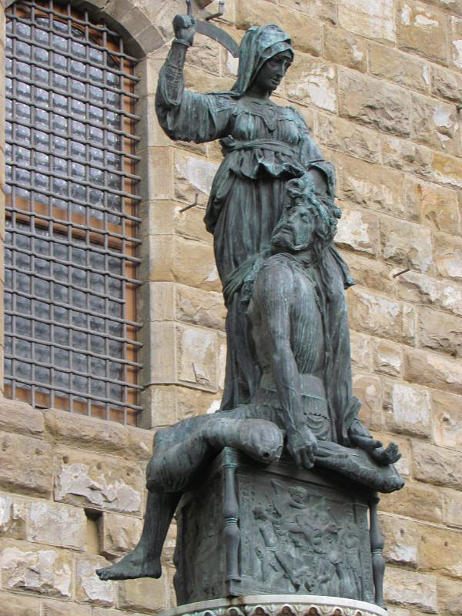
Donatello’s sculpture of Judith. Source of the sculpture: < https://www.wga.hu/html_m/d/donatell/3_late/judith/index.html>
Works Cited
Eisner, Elliot W. The arts and the creation of mind. Yale University Press, 2002.
Janson, Horst Woldemar, and Jenö Lányi. The Sculpture of Donatello: Critical catalogue. Vol. 2. Princeton University Press, 1957.
McHam, Sarah Blake. "Donatello's Bronze David and Judith as Metaphors of Medici Rule in Florence." The Art Bulletin83.1 (2001): 32-47.
Tolstoy, Leo. What is art?. Penguin UK, 1995.

